**CHANDIGARH UNIVERSITY**

**UNIVERSITY INSTITUTE OF ENGINEERING**

**DEPARTMENT OF COMPUTER SCIENCE & ENGINEERING**



|  |  |
| --- | --- |
| **Submitted By:** Sahil Kaundal  **Submitted To:** Neeru Sharma | |
| **Subject Name** | Programming Based Learning Java (Lab) |
| **Subject Code** | 20CSP-321 |
| **Branch** | Computer Science Engineering |
| **Semester** | 5th |

LAB INDEX

**NAME:** Sahil Kaundal **SUBJECT NAME:** PBLJ (Lab)

**UID:** 21BCS8197 **SUBJECT CODE:** 20CSP-321

**SECTION:** 20BCS_WM-616/A

|  |  |  |  |  |  |  |  |
| --- | --- | --- | --- | --- | --- | --- | --- |
| **Sr.No** | **Program** | **Date** | **Evaluation** | | | | **Sign** |
| **LW**  **(12)** | **VV**  **(10)** | **FW**  **(8)** | **Total**  **(30)** |
| 1. | Create an application to save the employee information using arrays. | 16/08/2022 |  |  |  |  |  |
|  |  |  |  |  |  |  |  |
|  |  |  |  |  |  |  |  |
|  |  |  |  |  |  |  |  |
|  |  |  |  |  |  |  |  |
|  |  |  |  |  |  |  |  |

**Experiment 1**

**Student Name:** Sahil Kaundal **UID:** 21BCS8197

**Branch:** BE CSE (Lateral Entry) **Section/Group:** 616/A

**Semester:** 5th **Date of Performance:** 16/08/2022

**Subject Name:** PBLJ Lab **Subject Code:** 20CSP-321

1. **Aim/Overview of the practical:**

Create an application to save the employee information using arrays.

**2. Apparatus / Simulator Used:**

1. Eclipse IDE - (Java)
2. NetBeans.

**3. Programs:**

import java.util.Scanner;  
class pblj1{  
 public static void main(String[] args) {  
 int[] empNo = {1001,1002,1003,1004,1005,1006,1007};  
 String[] EmpName = new String[] {"Ashish","Sushma", "Rahul", "Chahat", "Ranjan", "Suman","Tanmay"};  
 String[] JoinDate = new String[]  
 {"01/04/2009","23/08/2012","12/11/2008","29/01/2013","16/07/2005","1/1/2000","12/06/2006"};  
 String[] DesignCode = new String[] {"e","c","k","r","m","e","c"};  
 String[] Dept = new String[] {"R&D", "PM","Acct", "FrontDesk","Engg","Manufacturing","PM"};  
 int[] Basics = {20000,30000,10000,12000,50000,23000,29000};  
 int[] HRA = {8000,12000,8000,6000,20000,9000,12000};  
 int[] IT = {3000,9000,1000,2000,20000,4400,10000};  
 System.*out*.println("Enter the Employee ID");  
 String designationcodemean[] = new String[]  
 {"Consul"};  
 String designationOfEmployee[];  
 designationOfEmployee = new String[7];  
 int da_sal[];  
 da_sal = new int[7];  
 int salary[];  
 salary = new int[7];  
 for(int i=0; i<7; i++) {  
 if(designationOfEmployee[i]=="e"){  
 designationOfEmployee[i]="Engineer";  
 da_sal[i]= 20000;  
 }  
 else if(designationOfEmployee[i]=="c"){  
 designationOfEmployee[i]="Consultant";  
 da_sal[i]= 32000;  
 }  
 else if(designationOfEmployee[i]=="k"){  
 designationOfEmployee[i]="Clerk";  
 da_sal[i]= 12000;  
 }  
 else if(designationOfEmployee[i]=="r"){  
 designationOfEmployee[i]="Receptionist";  
 da_sal[i]= 15000;  
 }  
 else if(designationOfEmployee[i]=="m"){  
 designationOfEmployee[i]="Manager";  
 da_sal[i]= 32000;  
 }  
 }  
 for(int j=0;j<7;j++){  
 salary[j]=  
 (Basics[j]+HRA[j]+da_sal[j])-IT[j];  
 }  
 Scanner sc = new Scanner(System.*in*);  
 int empnumber = sc.nextInt();  
 int i=0,j=0;  
 while(empnumber>=1001 && empnumber<=1007){  
 if(empnumber==empNo[i]){  
 System.*out*.println(empNo[i] + " "  
 +EmpName[i] +" "+ JoinDate[i] +" "+ Dept[i] +" "+salary[i]);  
 j=1;  
 break;  
 }  
 ++i;  
 }  
 if (j==0)  
 System.*out*.println ("There is no Employee with this id: "+ empnumber);  
}  
 }

**4. Result/Output/Writing Summary:**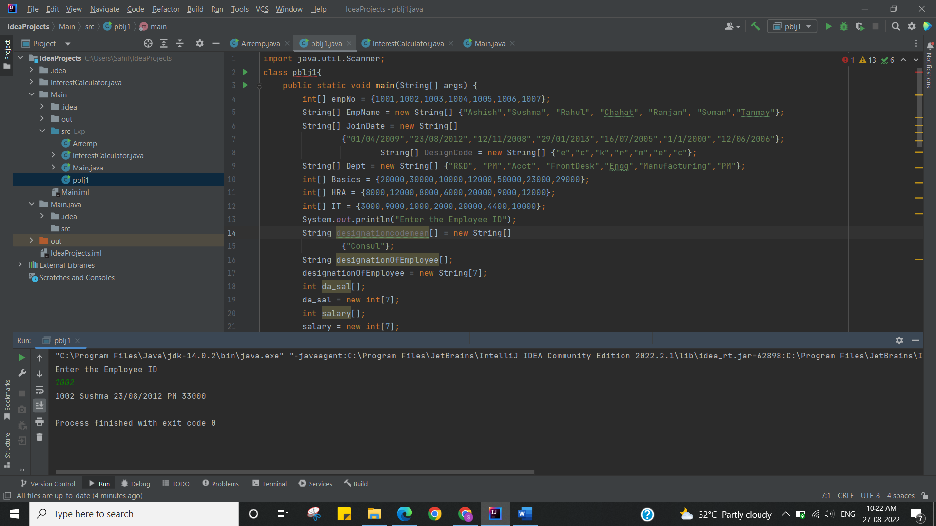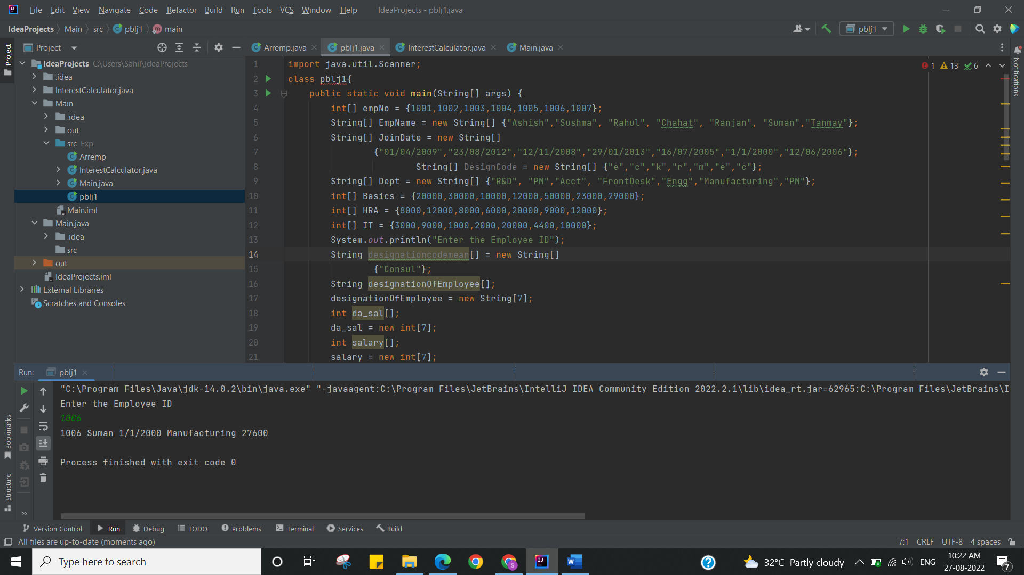

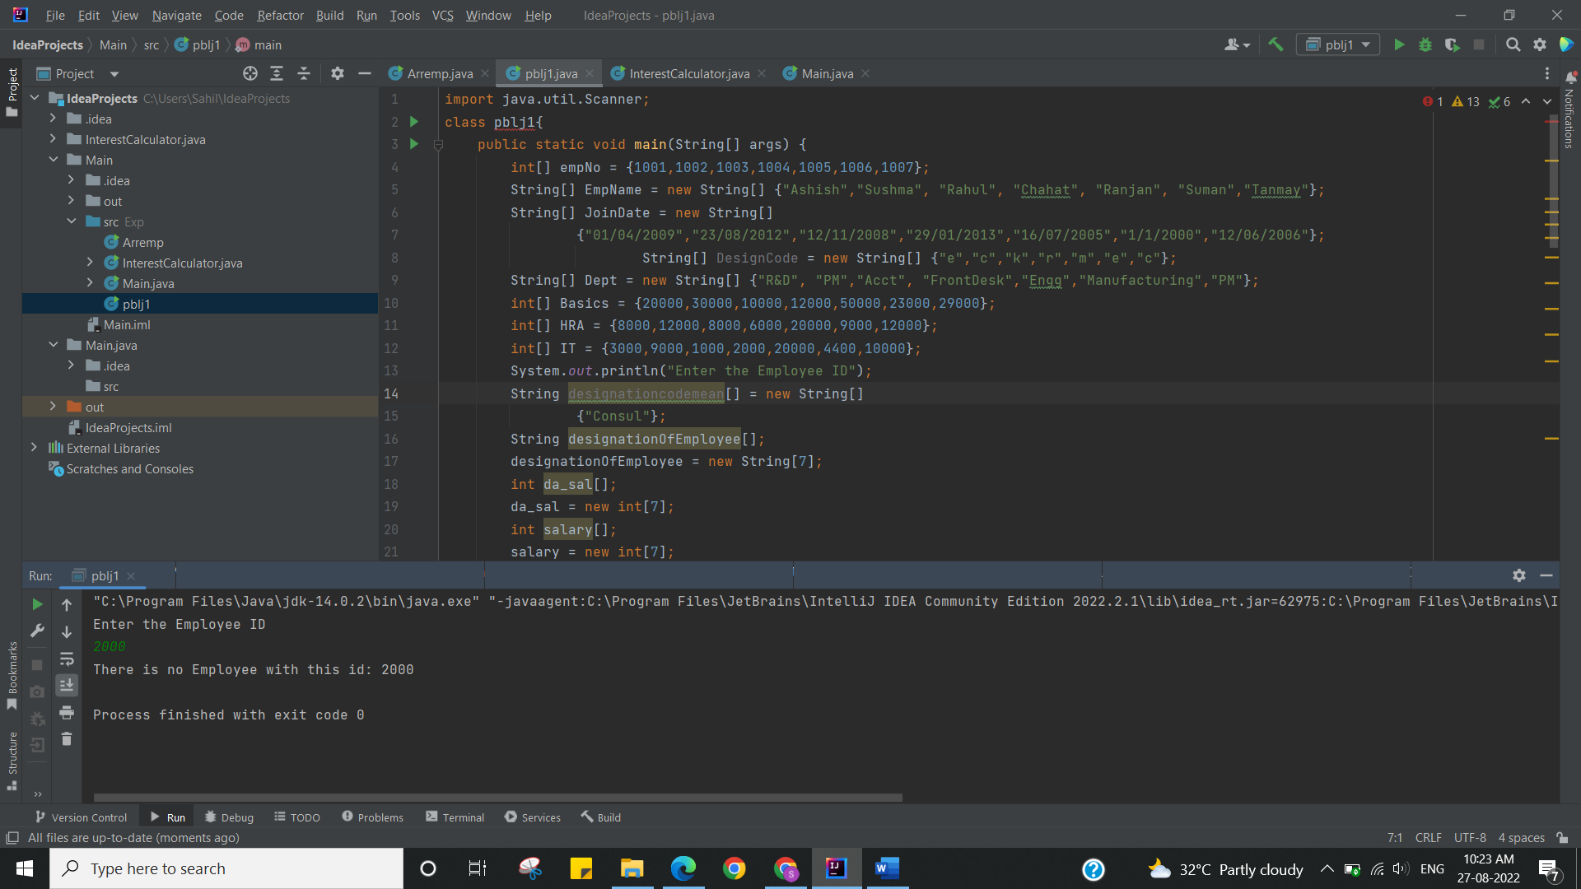

I have successfully done this experiment.

**Learning Outcomes (What I have learnt):**

1. Learn How to create the array.
2. Array manipulation in java.

**Evaluation Grid (To be created as per the SOP and Assessment guidelines by the faculty):**

|  |  |  |  |
| --- | --- | --- | --- |
| Sr. No. | Parameters | Marks Obtained | Maximum Marks |
| 1. |  |  |  |
| 2. |  |  |  |
| 3. |  |  |  |
|  |  |  |  |